Since the cast is limited to two characters, it makes sense that those two characters should be very distinct from one another. Randolf and Lynne are male and female characters for players who use gender to decide what kind of character they want to play.

Additionally, the design of each character should be indicative of their playstyle. Randolf is a fighter who mainly uses punches with a well-rounded moveset, and Lynne mainly uses kicks with rushdown-oriented moveset. So, for Randolf, I’d imagine a character design to reflect the nature of one who would have an answer for every situation, someone who looks calm under pressure, and have attire that would suit someone who fights with their fists. For Lynne, her design would need to reflect someone with a more aggressive nature, not afraid to get up close and personal, and have attire that would suit someone who fights with their legs.

Color is also a very important aspect of character design, to learn more about what colors are associated with, look to this website <http://www.color-wheel-pro.com/color-meaning.html>.

For examples in designing these archetypes, one could look to the designs of Ryu and Ken from Street Fighter and Ky Kiske and Sol Badguy from Guilty Gear.

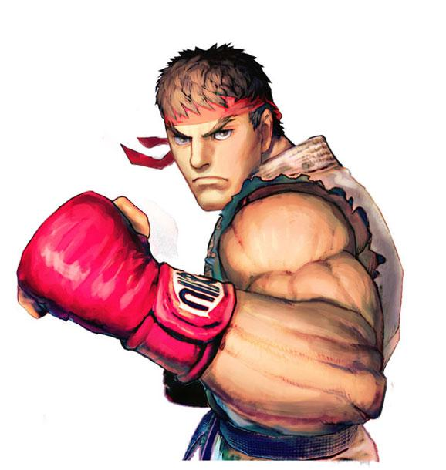

In Ryu, we see a very focused facial expression with an unwavering stare of stern confidence. His gi is the traditional white color, which can be seen as a respect for the martial arts he practices. His black belt also provides a contrast to his gi and helps divide the lower and upper half of his body. Lastly, his gloves are a bright red and match his red headband, that add a bit of color to his straightforward design.

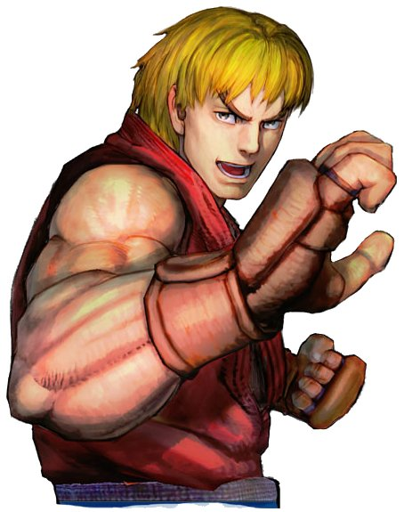

In Ken, we see eagerness in his facial expression. His hair is longer and brighter than Ryu’s, and he also wears a red gi to show that he is more aggressive and energetic. He also wears brown gloves that are not as flashy as his gi, perhaps showing that he can appreciate practicality now and again.

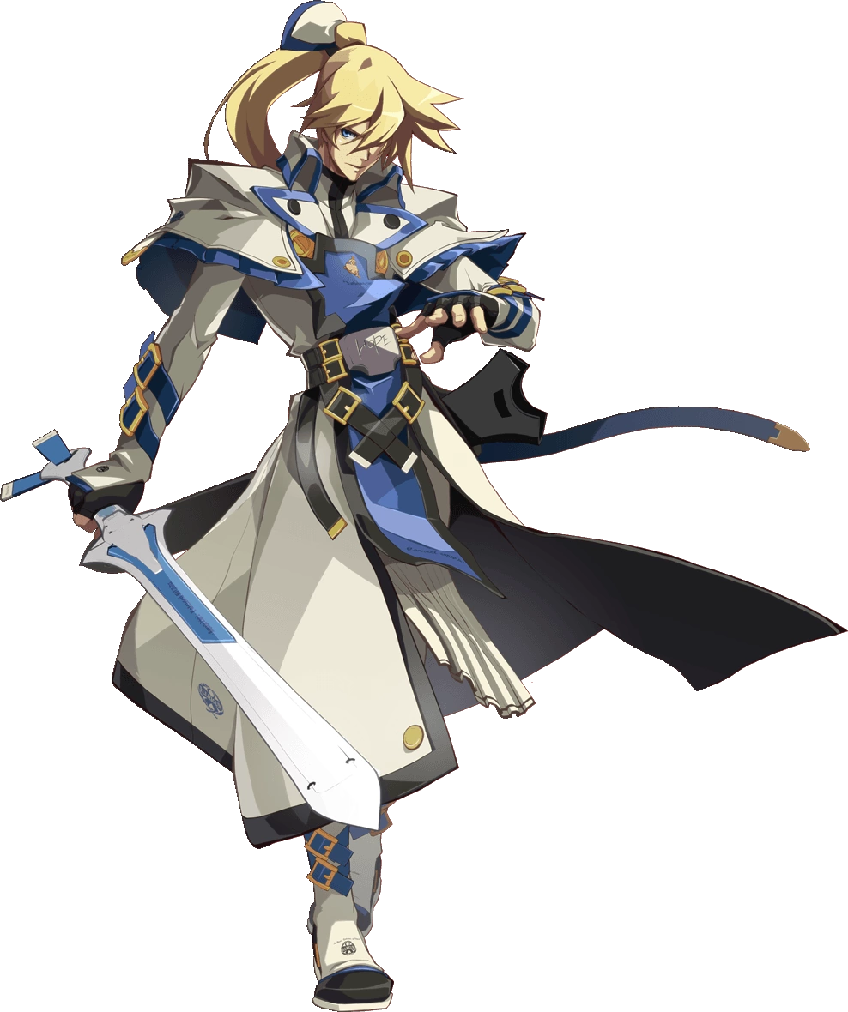

Ky Kiske shares similarities with Ryu in that most of his outfit is white, but he also has many blue sections. The white and blue go hand-in-hand as together they symbolize justice and wisdom, both of which are found within Ky’s character. His blonde hair also adds a shine to his character portrait. Lastly, Ky has long, flowing clothing that accentuate his regal status as king of the country Illyria.

Sol Badguy differs from Ky in many ways similar to the way Ken differs from Ryu. Sol’s hair is much less kept, his clothes are tighter, and his main colors are red and brownish-black. In addition to his rather strange-looking weapon, Junkyard Dog, this all builds him as a very rough and tough man which matches his rushdown-oriented, high damage gameplay.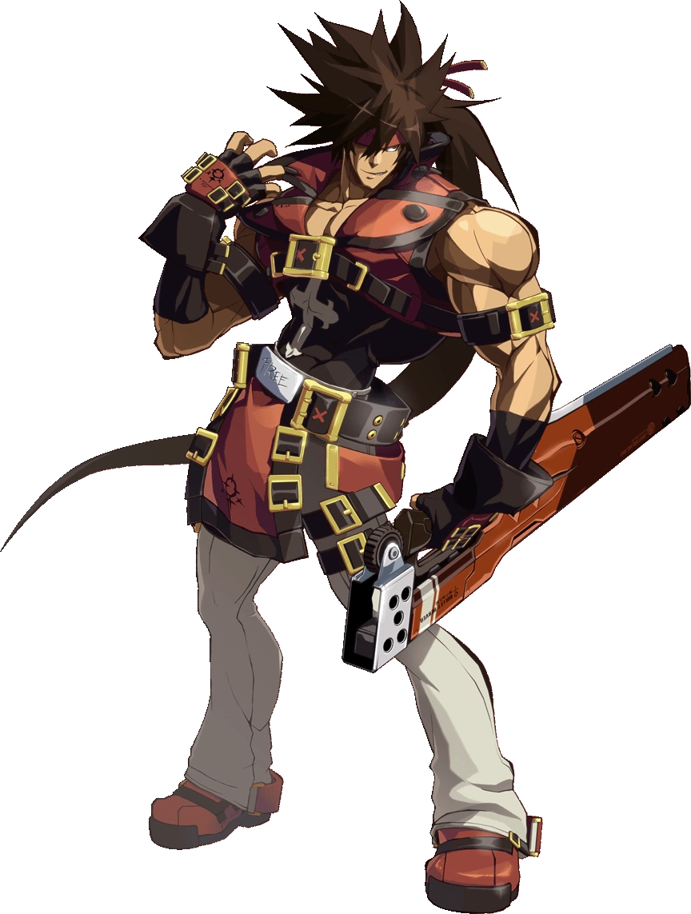

Now you certainly don’t have to take after these styles, I would actually prefer that you don’t oversaturate Randolf and Lynne with belts like our good friends from Guilty Gear. Since the game will take place in modern times, you can be creative with what they wear, just make sure to not make them too detailed so that they’re still easy to animate.

Lastly, here is a blog post that looks into the character designs of the anime Tengen Toppa Gurren Lagann: <https://myswordisunbelievablydull.wordpress.com/2016/10/31/cool-character-designs-gurren-lagann/>

The video version has visuals to match, so I recommend watching that but you can refer to the text at later points if you want to remember specific details. Be sure to look up more information on character design as well, there may be some important things you could learn that I haven’t mentioned here.